

ADDIS ABABA UNIVERCITY

ADDIS ABABA INSTITUTE OF TECHNOLOGY

CENTER OF INFORMATION TECHNOLOGY AND SCIENTIFIC COMPUTING

DEPARTMENT OF SOFTWARE ENGINEERING

Lecture One Based Assignment

**Submitted By:** Biruk Kassaw – atr/2802/11

**Submitted To:** Mr. Fitsum Alemu

May 2020

Acknowledgement

I would like to express my special thanks of gratitude to my teacher Mr. ***fitsum Alemu*** who gave me the golden opportunity to do this wonderful project on the topic Evolution of Internet, which also helped me in doing a lot of Research and I came to know about so many new things I am really thankful to him. Secondly, I would also like to thank my friends who helped me a lot in finalizing this assignment within the limited time frame.

Abstract

By definition the Internet is a worldwide, publicly accessible series of interconnected [computer networks](https://en.wikipedia.org/wiki/Computer_network) that transmit [data](https://en.wikipedia.org/wiki/Data) by [packet switching](https://en.wikipedia.org/wiki/Packet_switching) using the standard Internet Protocol. How did this technology come to be so popular and so widely used around the world? In this document we will see the history of the Internet from the beginning to what it is today. In addition, we will see the evolution of websites, types of websites and the guide lines to evaluate a website.

Contents

History of the Internet 1

Introduction 1

Creation 1

Observation and assessment of 5 popular websites 3

Google 3

YouTube 5

W3schools 8

Amazon 10

Wikipedia 11

List of 5 websites each on the 12 categories of websites 13

1. Portal 13

2. News 13

3. Informational 14

4. Business/ Marketing 14

5. Educational 14

6. Entertainment 15

7. Advocacy 15

8. Blog 15

9. Wiki 15

10. Social Network 16

11. Content Aggregator 16

12. Personal 16

Guidelines for evaluating the value of a Web site 17

Content Quality 17

1. Authority 17

2. Purpose 17

3. Coverage 18

4. Timely 18

5. Objectivity 19

6. Accuracy 19

Design Quality 19

1. Aesthetics 19

2. SEO and Social Networking 20

3. Responsiveness 20

Organization Quality 20

User-friendly Quality 21

Learnability 21

Errors 21

Evaluation of websites based on the above guidelines 21

Wikipedia 21

Content quality 21

Design quality 22

Organization quality 22

User-friendly Quality 22

Reference 23

Table of figures

Figure 1 Google 1998 3

Figure 2 Google 2010 3

Figure 3 Google 2020 4

Figure 4 YouTube 2006 5

Figure 5 YouTube 2013 6

Figure 6 YouTube 2020 7

Figure 7 w3schools 2000 8

Figure 8 w3schools 2010 9

Figure 9 w3schools 2020 9

Figure 10 Amazon 2000 10

Figure 11 Amazon 2010 10

Figure 12 Amazon 2020 11

Figure 13 Wikipedia 2000 11

Figure 14 Wikipedia 2010 12

Figure 15 Wikipedia 2020 13

# History of the Internet

## Introduction

The Internet is a massive network of networks, a networking infrastructure. It connects millions of computers together globally, forming a network in which any computer can communicate with any other computer as long as they are both connected to the Internet.

By definition the [Internet](https://en.wikipedia.org/wiki/Internet) is a worldwide, publicly accessible series of interconnected [computer networks](https://en.wikipedia.org/wiki/Computer_network) that transmit [data](https://en.wikipedia.org/wiki/Data) by [packet switching](https://en.wikipedia.org/wiki/Packet_switching) using the standard [Internet Protocol](https://en.wikipedia.org/wiki/Internet_Protocol). How did this technology come to be so popular and so widely used around the world? Was it always so large and extensive, filled with information about just about anything you can possibly imagine and accessible from almost anywhere, anytime? The answer is no and it is important to understand where it came from to understand how to utilize it to its fullest potential now. In this section we will see the history of the Internet from the beginning to what it is today.

## Creation

The Internet’s origins have their roots in a military project, the Semi-Automatic Ground Environment (SAGE) program in USA, which networked country-wide radar systems together for the first time. This was created around 1958 as part of an attempt to regain the lead in technology from the Soviet Union which had recently launched Sputnik (the first man-made satellite to orbit the earth).

The idea of a ‘resource-sharing’ network first emerged in ARPA in 1966 (Naughton [1999](https://www.tandfonline.com/doi/full/10.1080/23738871.2016.1157619), 84). Design work, conducted in a collegial style (Abbate [1999](https://www.tandfonline.com/doi/full/10.1080/23738871.2016.1157619), 56) unusual in the defense industry, then proceeded over the next two years. The contract to build the network was awarded in early 1969 to Bolt, Beranek and Newman, a Boston-based consultancy firm with strong links to MIT.

The technological and conceptual challenges that faced the network's designers have long been obliterated by the omniscience of hindsight, but they were formidable.[7](https://www.tandfonline.com/doi/full/10.1080/23738871.2016.1157619) Given that the network was supposed to facilitate the sharing of expensive and scarce resources, namely the mainframe computers that ARPA had funded in various research center across the country, a key obstacle to overcome was the fact that these machines were incompatible with one another. For each of them to participate in a network would require the creation of complex, customized networking software which would enable each machine to communicate with every other machine on the system. In the end, this problem was not so much solved as side-stepped: it was decided to build a ‘sub-net’ of identical minicomputers (which came to be called ‘interface message processors’ or IMPs) each linked to a single mainframe ‘host’. In that way the task of writing networking software for a host was greatly reduced: it would simply have to communicate with a single machine – the IMP assigned to it.

Given the technical challenges implicit in the task, the ARPANET was built with astonishing speed. By 1972, the network was essentially complete; the 15 original sites were all connected and operational and a major public demonstration of the system was held in Washington, DC in the Autumn of that year.

From the perspective of the present, three aspects of the ARPANET project stand out.

The first is that while it was a triumph of project management in the conventional sense, success was achieved in an unusually collegial way. This was sensible for several reasons: the network was intended to link high-profile researchers working in elite institutions, and such individuals are not easily herded, plus it made sense to harness the collective IQ of that community at every level, including that of graduate students. For that reason, for example, design of the central protocols of the network was entrusted to a Network Working Group that largely consisted of students. In this way was established the collaborative ethos that has been an important feature of Internet technical development up to the present day.[8](https://www.tandfonline.com/doi/full/10.1080/23738871.2016.1157619)

Secondly, the ARPANET provides an interesting case study in the extent to which technologies are socially shaped. In this case, the shaping was done by the network's users, first of all because many of them were actively involved in the design of the network and therefore they were both designers and ‘customers’, that is, users. And in the latter capacity, they sprang some major surprises on ARPA managers. The network was intended to be a facility for resource-sharing, but it transpired that it was not much used for this original purpose. Instead, its users employed it mostly for communicating with one another, sharing files and software, and for sending and receiving email (Abbate 1999, 108). In that sense, the community of users came up with a new conception of what ‘networking’ meant – not so much the sharing of *machines* as the linking of *people*. As Abbate puts it, ‘Increasingly people within and outside the ARPA community would come to see the ARPANET not as a computing system but rather as a communications system’ (Abbate [1999](https://www.tandfonline.com/doi/full/10.1080/23738871.2016.1157619), 111). Given the technical sophistication of the network's users, it is also not surprising that they were vocal in their demands for system modification and innovation. But while many user tweaks were ‘encouraged or at least tolerated’ by ARPA, the agency did not always welcome users’ attempts to steer the evolution of the system (Abbate [1999](https://www.tandfonline.com/doi/full/10.1080/23738871.2016.1157619), 93). Its reluctance in this respect may not have been due to hierarchical reflexes so much as the need to reassure Congress that the network was not a publicly funded experiment in computer science, but an administrative tool useful for military and defense purposes.

# Observation and assessment of 5 popular websites

## Google

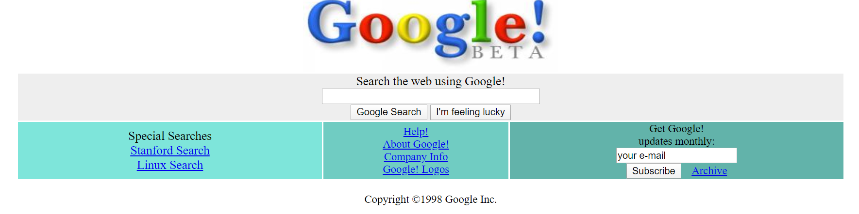

Figure Google 1998

The Google website in 1998 was made using only html since there was no CSS. It was not that much attractive to the user as it is today. The website does not have navigation bar at the top and the elements do not have enough margin between them. Its was not the stable version but the beta version available to the users in 1998.

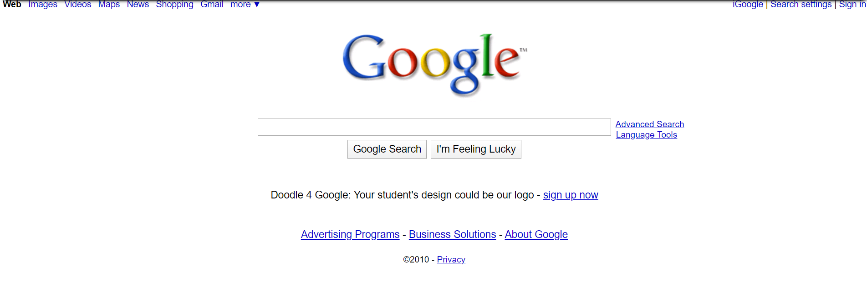

Figure Google 2010

In 2010 google was different by many things from the 1998. Some of them are:

* A nav bar was available at the top.
* Advanced search was available.
* The elements in the website have better margin than the 1998.

Google in 2010 was more attractive and responsive than it was in 1998.

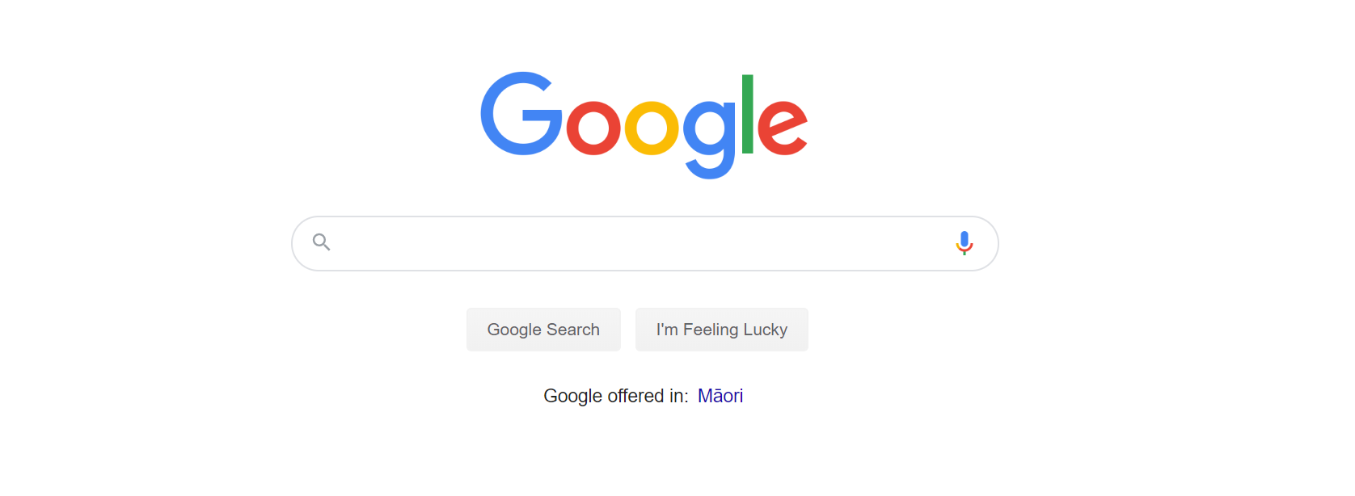

Figure Google 2020

Now in 2020 google is the most popular search engine, an average internet user conducts between 3 and 4 Google searches per day. New HTML5 elements are used to make the website. The colors on the logo has changed to brighter colors. The search box has round corners and contains two buttons one for voice search and the other to search the text on the search box It is now more attractive to the user than it was ever before.

## YouTube

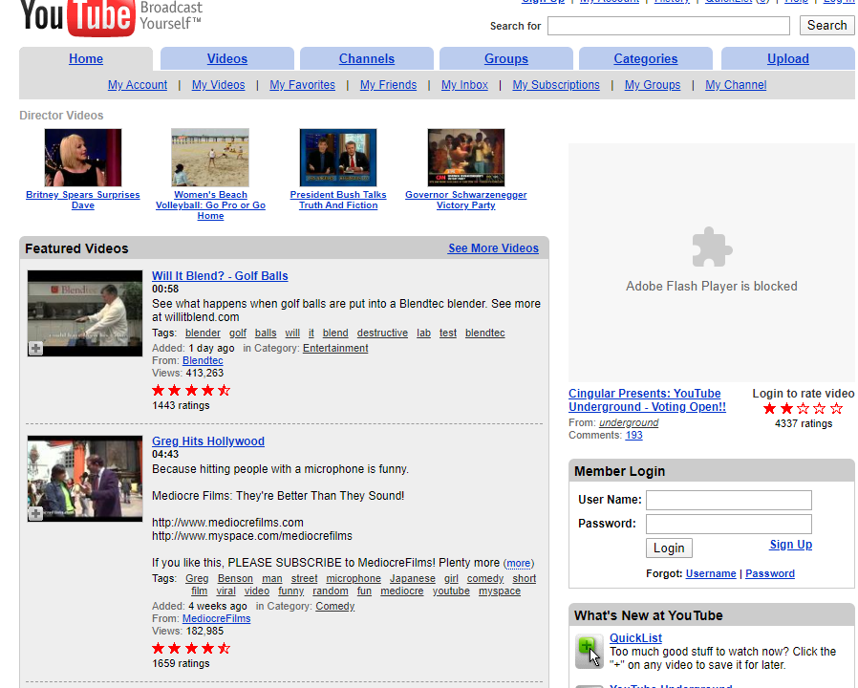

Figure YouTube 2006

Since HTML5 video and audio elements were not available in 2006 to watch a video in YouTube ***Adobe Flash Player*** have to be installed in the browser. All the videos have ratings given by the viewers. To give rate to videos a user must log in into his account. In addition to ratings videos have comments and favorited.

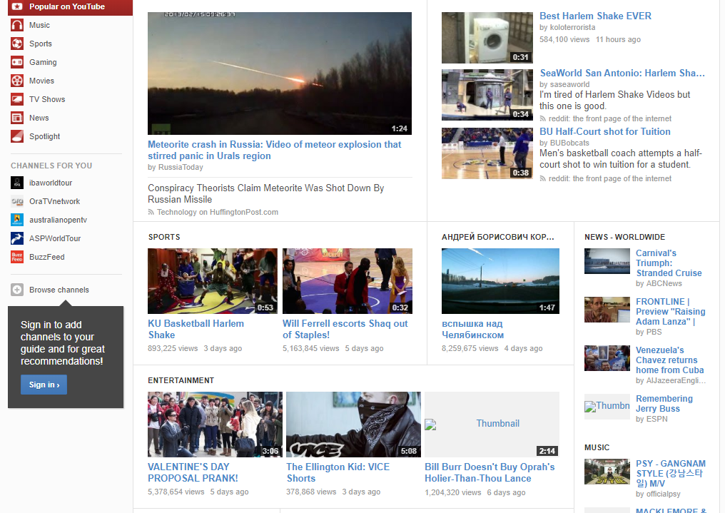

Figure YouTube 2013

In 2013 YouTube has improved in a lot of ways compared to the 2006. some of them are:

* Likes comments were available.
* Favorited and ratings were replaced by likes and dislikes.
* Subscription to channels was available to the viewers.
* The navigation bar which was on the top moved to the left side.
* The underline on links were removed.

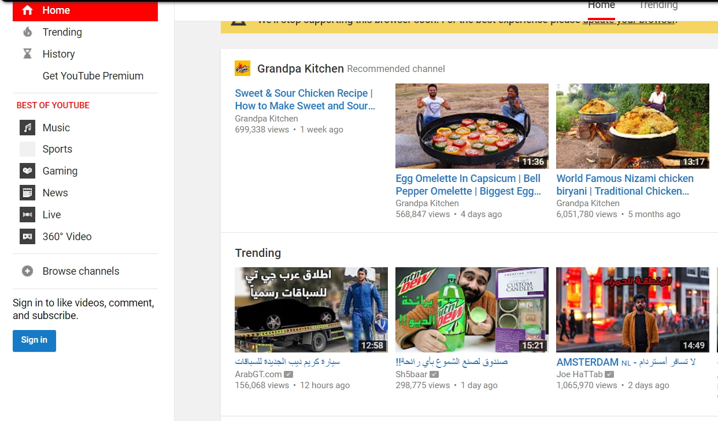

Figure YouTube 2020

In 2020 The total number of people who use YouTube are 1,300,000,000 and 300 hours of video are uploaded to YouTube every minute. HTML5 audio and video elements are available as a result videos can be played with out using flash players. YouTube has a feature called dark mode for people who prefer dark over light and for usage in a low-level light. The logo has changed. Popular channels have a mark for verification by viewers.

## W3schools

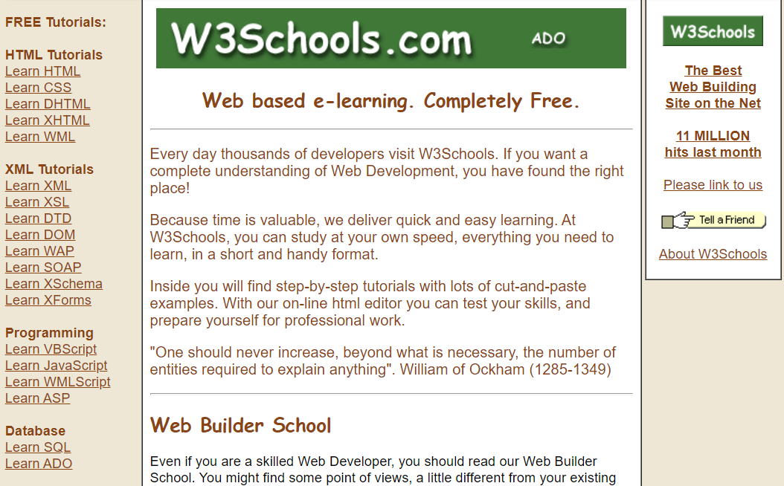

Figure w3schools 2000

1999 was the beginning year of e-learning and w3schools was one of the free web-based e-learning websites. The website does not have a navigation bar at the top. The tutorials were listed in the left in underlined hyperlink.

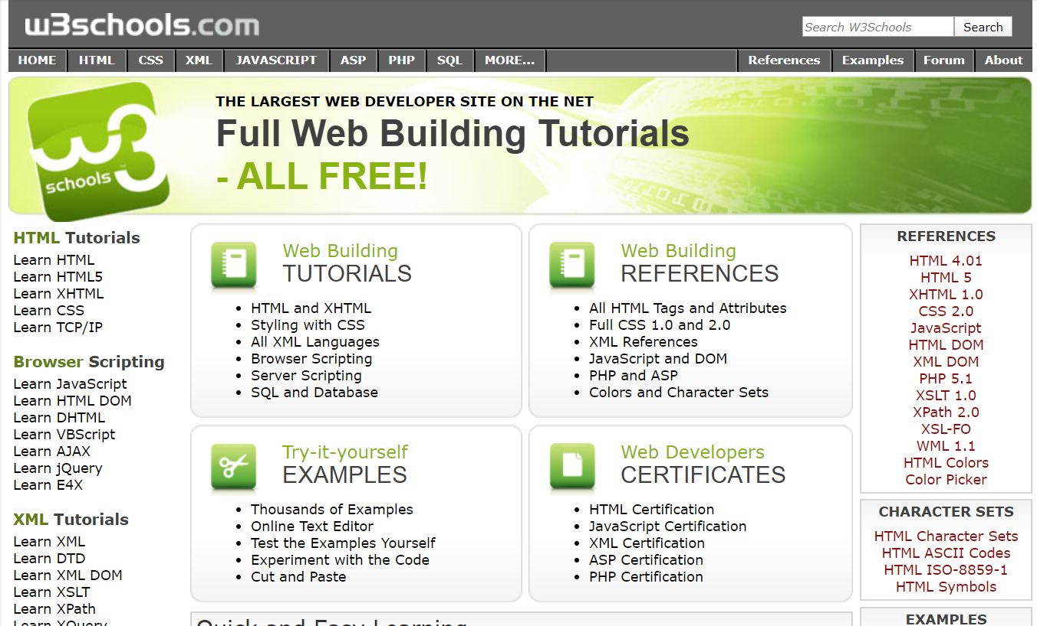

Figure w3schools 2010

In 2010 w3schools had many additional features compared with the 2000 w3schools. It had interactive navigation bar at the top, a search input and the website was much more attractive. It had a feature called try it your self in which a user can try the examples in different ways on the browser. The logo was changed and the underline from the hyperlinks were removed.

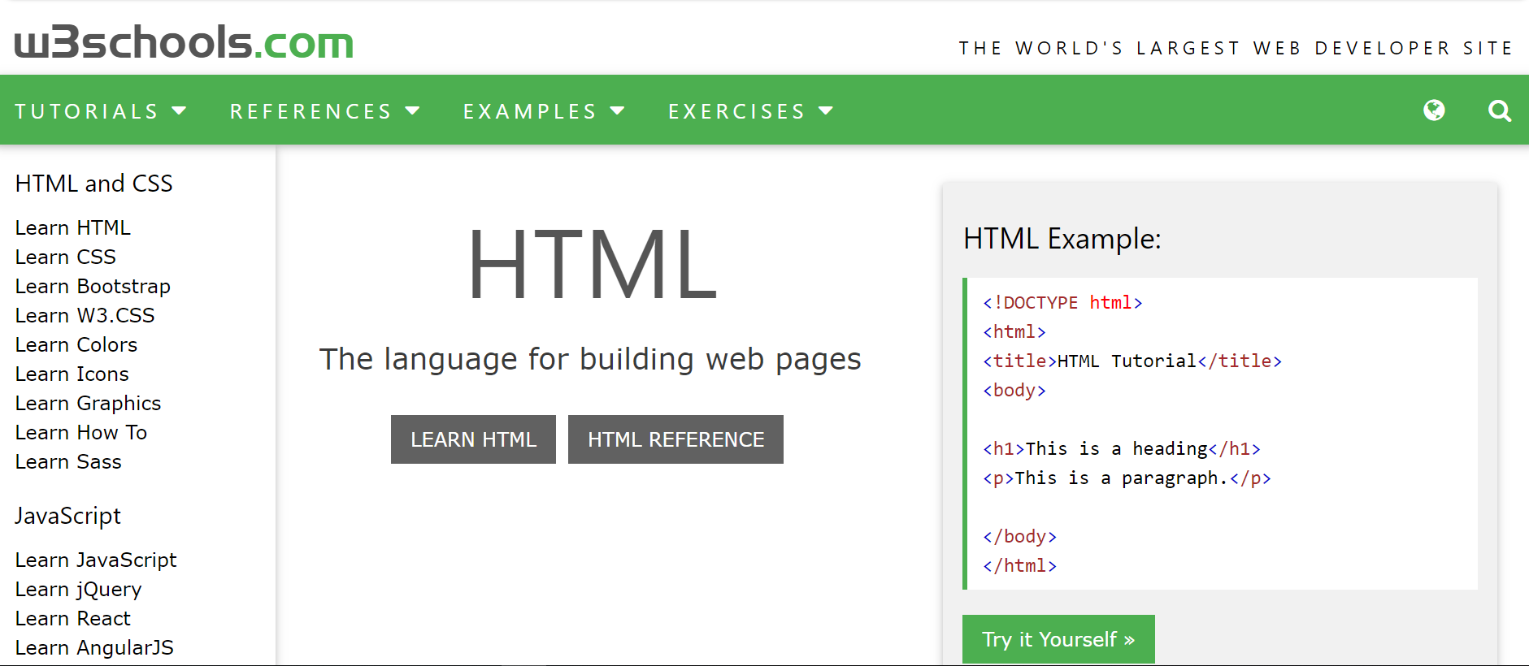

Figure w3schools 2020

In 2020 w3schools is one of the largest web developer sites. The web site is interactive and responsive which makes it easy to be used by smaller devices. It has compilers for different programing languages in the website to make it easier to try programs on the browser. The foreground and background colors have a medium contrast which makes reading easier.

## Amazon

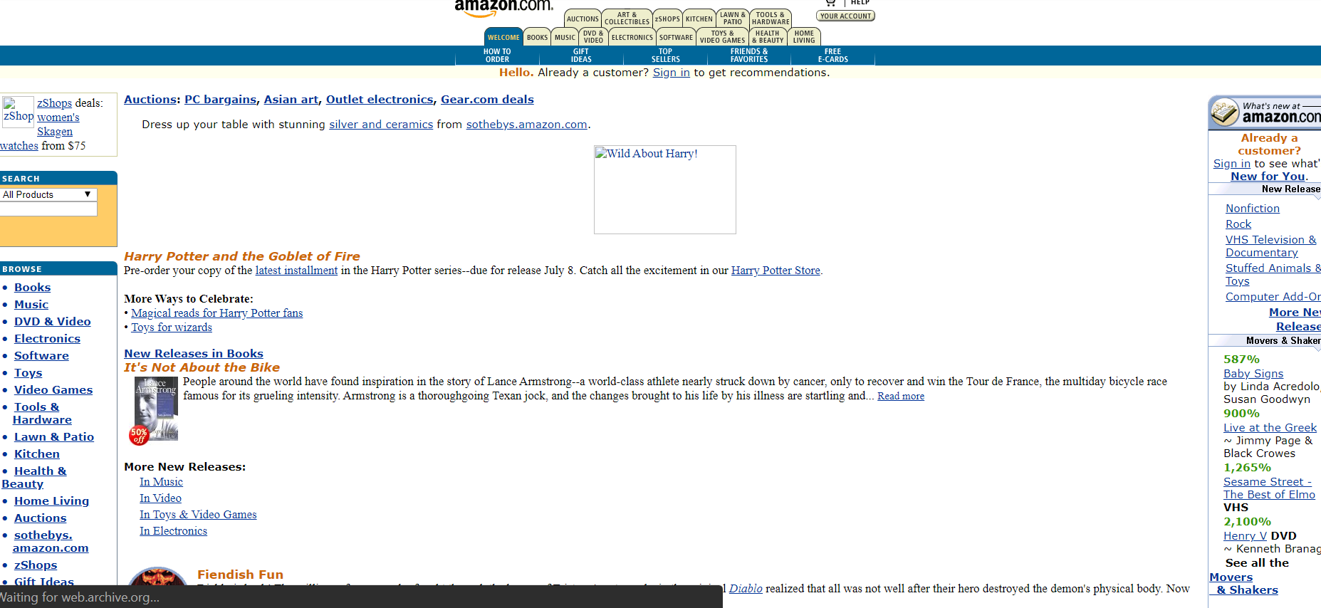

Figure Amazon 2000

In 2000 amazon was not as popular as it is today there were not as many products and users as there are today. On searching for a product, a user can search either from all the products or he can filter them using the drop-down menu above the search box. Using the website in smaller devices was difficult and there were some contents that cannot be clearly seen. The hyperlinks were blue and underlined.

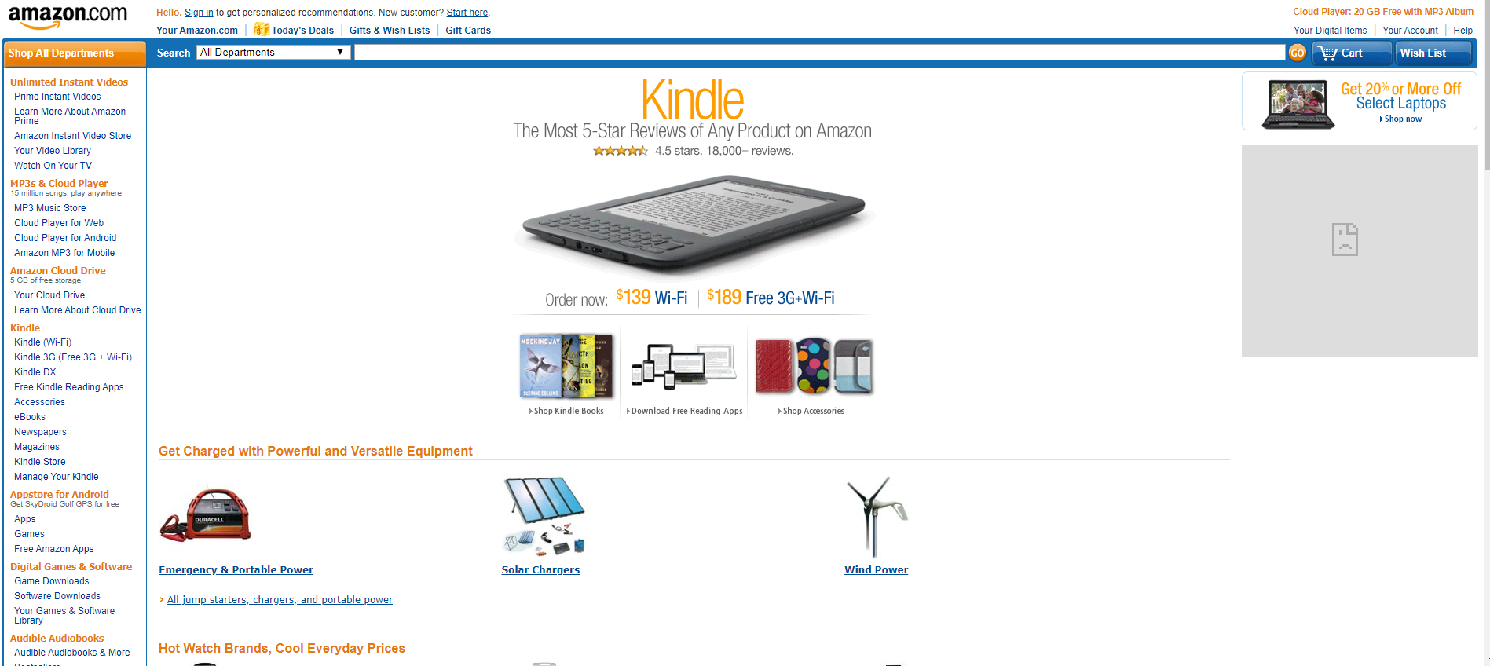

Figure Amazon 2010

In 2010 the amazon website has a feature called wish list in which the user can store what he wants to buy in the future. The underline was removed from the hyperlinks. The navigation bar at the top was removed.

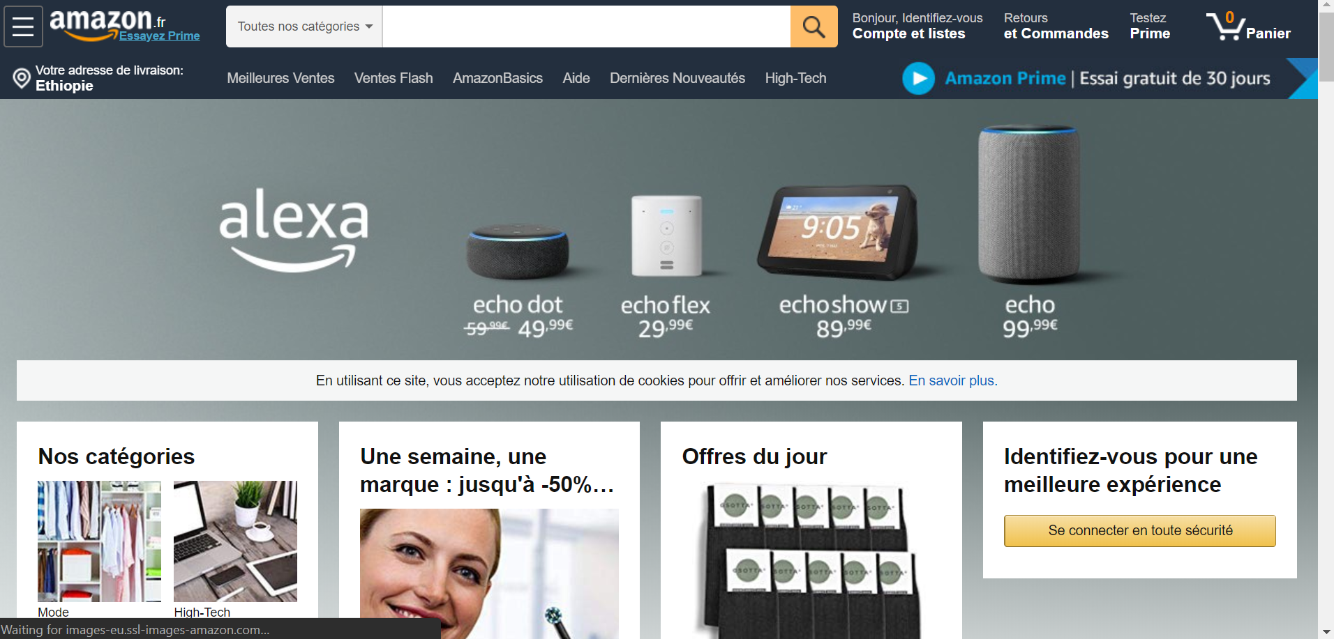

Figure Amazon 2020

In 2020 the amazon website is responsive and very easy to use on smaller devices. There is a hamburger sign at the top left corner which displays the navigation bar.

## Wikipedia

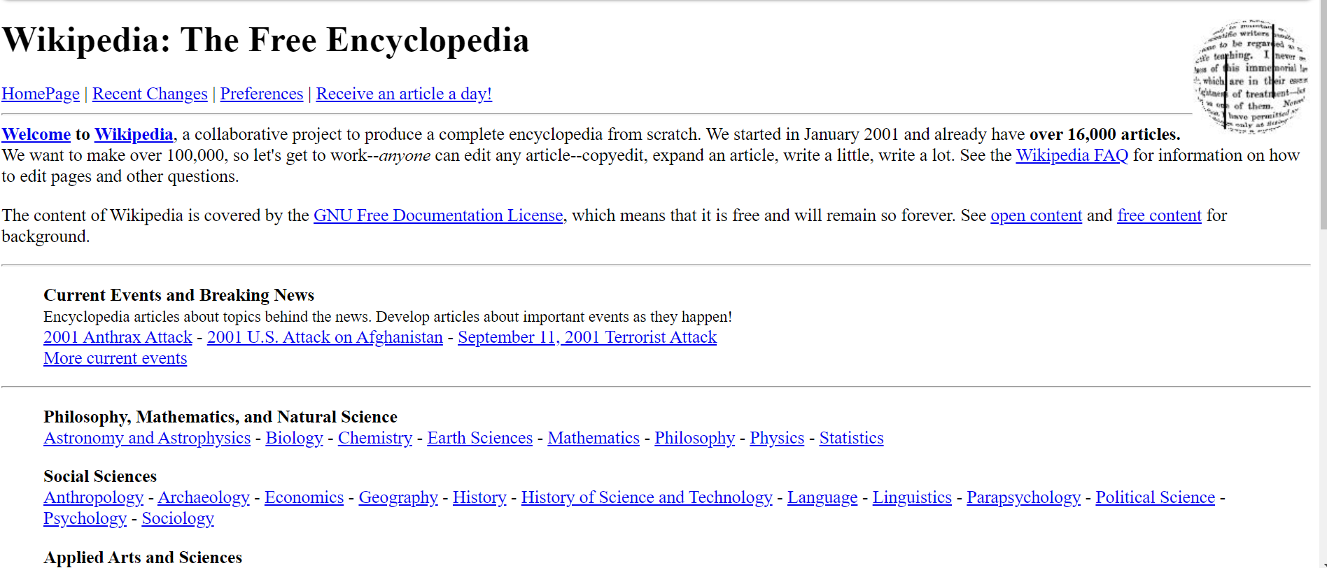

Figure Wikipedia 2000

In 2000 the Wikipedia website was group of sections separated by horizontal line(<hr>). The logo was a simple globe on the right top corner. As we can see from the picture no styles or attributes were used to change color, font and alignment. The search box was at the bottom of the page.

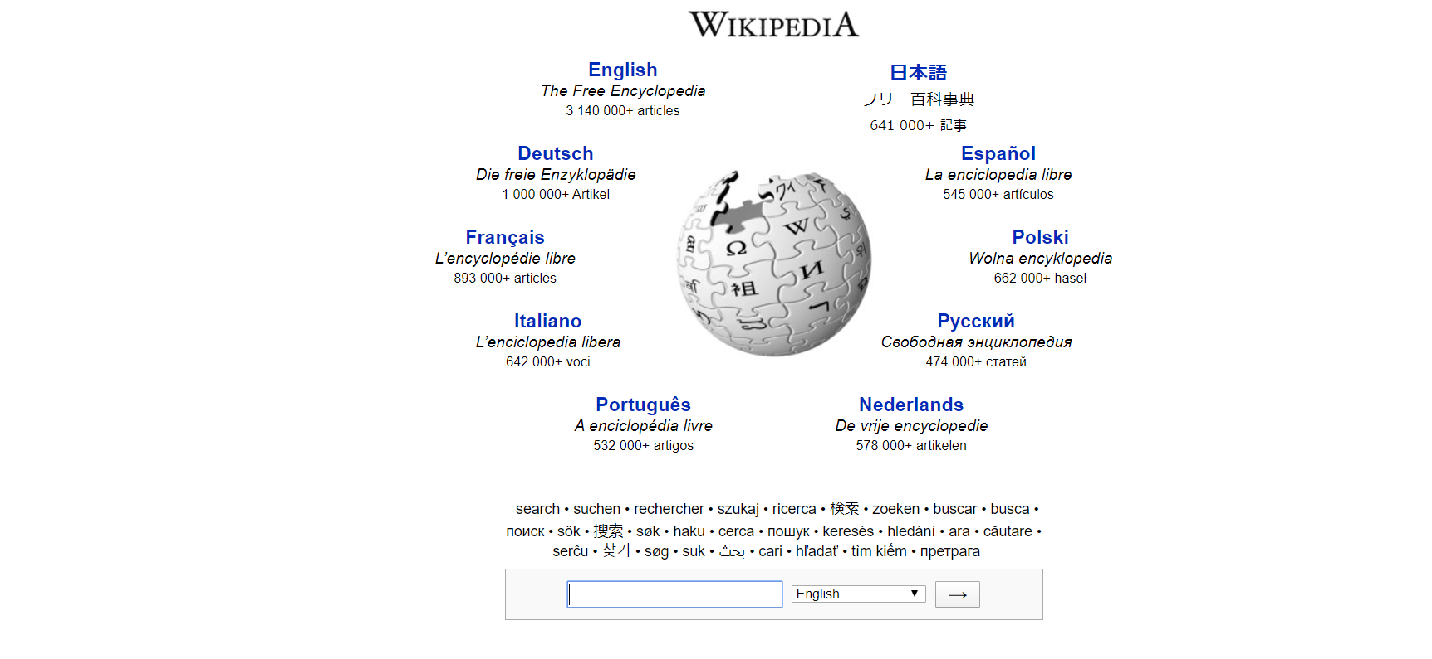

Figure Wikipedia 2010

In 2010 Wikipedia had changed logo and its logo was placed at the top surrounded by language preferences. The search box was not placed at the bottom of the page as in 2000 but below the logo. To search first the user inserts the keyword then choose language from the dropdown then click the arrow key.

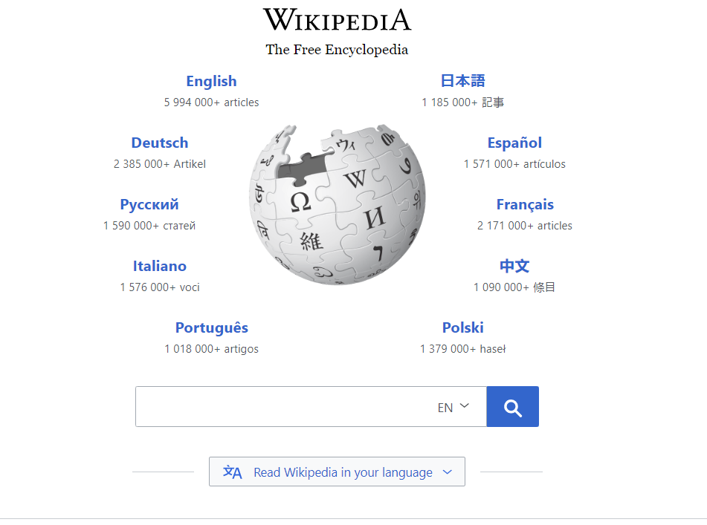

Figure Wikipedia 2020

# List of 5 websites each on the 12 categories of websites

## Portal

A **web portal** is a specially designed [website](https://en.wikipedia.org/wiki/Website) that brings information from different sources, like [emails](https://en.wikipedia.org/wiki/Email), [online forums](https://en.wikipedia.org/wiki/Internet_forum) and [search engines](https://en.wikipedia.org/wiki/Web_search_engine), together in a uniform way.

1. Google <https://www.google.com/>
2. Yahoo <https://www.yahoo.com/>
3. MSN <https://www.msn.com/en-xl/>
4. Windows live <https://outlook.live.com/owa/>
5. Baidu <https://www.baidu.com/>

## News

 A news website is a website which serves the news online.

1. The guardian <https://www.theguardian.com/>
2. The Washington post <http://washingtonpost.com/>
3. Fox News <https://www.foxnews.com/>
4. Google News <https://news.google.com/>
5. Yahoo News <http://news.yahoo.com/>

## Informational

An informational website is a site with a purpose to provide detailed information about a specific topic, such as science, economics, movies, etc.

1. Wikipedia <https://www.wikipedia.org/>
2. Stack overflow <https://stackoverflow.com/>
3. Nobel Prize <https://www.nobelprize.org/>
4. Guinness World Records <https://guinnessworldrecords.com/>
5. CNET <https://www.cnet.com/>

## Business/ Marketing

A business/marketing website is a website that supplies information and advice on current markets.

1. Yahoo finance <http://finance.yahoo.com/>
2. Forbes <https://www.forbes.com/>
3. MSN <https://www.msn.com/>
4. Bloomberg <https://www.bloomberg.com/>
5. All business <https://www.allbusiness.com/>

## Educational

Educational websites are websites that contains videos, audios or topic related resources that act as tools to enhance learning and supplement classroom teaching.

1. Coursera <https://www.courser.org/>
2. EdX <https://www.edx.org/>
3. Academic Earth <https://www.acadamicearth.org/>
4. Internet Archive <https://www.archive.org/>
5. Big Think <https://www.bigthink.org/>

## Entertainment

Entertainment websites are websites which contain entertaining content including live video streaming, video chat communications, multi-player gaming, music and videos streaming.

1. YouTube <https://www.youtube.com/>
2. Facebook <https://www.facebook.com/>
3. Instagram <https://www.instagram.com/>
4. 1up <https://www.1up.com/>
5. Adventure Games <https://www.adventuregamers.com/>

## Advocacy

Advocacy websites are websites that aims to influence decisions within political, economic, and social institutions.

1. World Advocacy   <http://www.worldadvocacy.com>
2. Greenpeace  <http://www.greenpeace.org>
3. Sierra Club  [http://www.sierraclub.org](http://www.sierraclub.org/)
4. Environmental Defense Action Fund  [http:/www.undoit.org](http://www.undoit.org/)
5. Jane Goodall Institute  [http://www.janegoodall.org](http://www.janegoodall.org/)

## Blog

A blog is a discussion website published on the World Wide Web consisting of different, often informal diary-style text entries (posts).

1. **WordPress.org** <http://www.wordpress.org>/
2. Wix.com <http://www.wix.com>/
3. **WordPress.com** <http://www.wordpress.com>/
4. **Medium.com**  <http://www.medium.com>/
5. **Weebly.com** <http://www.weebly.com>/

## Wiki

A wiki is a website that allows the site visitors to add and edit content. Generally, site visitors use their browser to edit text without requiring HTML code. Additionally, some Wikis allow adding and editing of graphics, tables and interactive components.

1. Wikipedia. <https://www.wikipedia.org/>
2. Wikia <https://www.wikia.com/>
3. Wikihow <https://www.wikihow.com/>
4. Wiktionary <https://www.wiktionary.org/>
5. Word reference <https://www.wordreference.com/>

## Social Network

Social Network websites are websites which let the users stay connected with friends, family, colleagues, customers, or clients.

1. Facebook <https://www.facebook.com/>
2. Instagram <https://www.instagram.com/>
3. Twitter <https://www.twitter.com/>
4. [**WhatsApp**](https://www.whatsapp.com/) <https://www.whatsapp.com/>
5. WeChat <https://www.wechat.com/>

## Content Aggregator

A content aggregator website is a site that collects data from other sources across the internet and puts the information in one place where users can access it.

1. Alltop <https://www.alltop.com/>
2. Popurls <https://www.popurls.com/>
3. [The Web List](http://theweblist.net/) <https://www.theweblist.net/>
4. Google News <https://news.google.com/>
5. Yahoo News <http://news.yahoo.com/>

## Personal

Personal websites are websites created by an individual to contain content of a personal information rather than content pertaining to a company, organization or institution.

1. Messi <https://www.messi.com/>
2. Ronaldo <https://www.cristianoronaldo.com/>
3. Gary Sheng <https://www.garysheng.com/>
4. Raf Derolez <https://www.rafaelderolez.com/>
5. Pascal van Gemert <https://www.pascalvangemert.com/>

# Guidelines for evaluating the value of a Web site

With increased access to the Internet, Web sites are becoming popular educational resources. Not every site makes a good resource, so how does one decide whether a site is worth using? Because of the inconsistency of information on the Internet, it is very important to develop evaluation skills to assist identifying quality Web pages.  There are four (4) basic criteria that should be applied when evaluating any Web site:***content quality***, ***design quality***, ***organization quality***, and ***user-friendly quality*.**  For each criterion, there are several sub-criteria.  The more questions the answer is "yes", the more likely the Web site is one of quality.

## Content Quality

It is generally agreed that quality of the content is an important criterion which deals with the characteristics of websites’ information. The following indicators and check elements are the most important relating to the content quality criterion:

### Authority

Authority reveals that the person, institution or agency responsible for a site has the qualifications and knowledge to do so. Evaluating a web site for authority:

* Authorship: It should be clear who developed the site.
* Contact information should be clearly provided: e-mail address, phone number, and fax number.
* Credentials: the author should state qualifications, credentials, or personal background that gives them authority to present information.

### Purpose

The purpose of the information presented in the site should be clear. Some sites are meant to inform, persuade, state an opinion, entertain, or parody something or someone. Evaluating a web site for purpose:

* Does the content support the purpose of the site?
* Is the information geared to a specific audience (students, scholars, general reader)?
* Is the site organized and focused?
* Are the outside links appropriate for the site?
* Does the site evaluate the links?

### Coverage

It is difficult to assess the extent of coverage since depth in a site, through the use of links, can be infinite. One author may claim comprehensive coverage of a topic while another may cover just one aspect of a topic. Evaluating a web site for coverage:

* Does the site claim to be selective or comprehensive?
* Are the topics explored in depth?
* Compare the value of the site’s information compared to other similar sites.
* Do the links go to outside sites rather than its own?
* Does the site provide information with no relevant outside links?

### Timely

Timely of the site refers to:

* how current the information presented is? how often the site is updated or maintained. It is important to know when a site was created, when it was last updated, and if all of the links are current. Evaluating a web site for currency involves finding the date information was:
* first written
* placed on the web
* last revised

Then ask if:

* Links are up-to-date?
* Links provided should be reliable. Dead links or references to sites that have moved are not useful?
* Information provided so trend related that its usefulness is limited to a certain time period?
* the site been under construction for some time?

### Objectivity

Objectivity of the site should be clear. Beware of sites that contain bias or do not admit its bias freely. Objective sites present information with a minimum of bias. Evaluating a web site for objectivity:

* Is the information presented with a particular bias?
* Does the information try to sway the audience?
* Is the site trying to explain, inform, persuade, or sell something?

### Accuracy

There are few standards to verify the accuracy of information on the web. It is the responsibility of the reader to assess the information presented. Evaluating a web site for accuracy:

* Is the information precise there is no spelling errors or grammar, and the sources of information is identified?

## Design Quality

This dimension concerns the visual characteristics of websites’ design that attracts the users and encourages them to stay longer time viewing the website and re-enter it. The following indicators and check elements are the most important relating to the design quality dimension:

### Aesthetics

Some say beauty is relative, but that does not mean that there are not defined aesthetic principles that should guide website design. The best type of design will align with the brand, create a positive impression for visitors, be clean, and it will complement the content that is being communicated. To test the effectiveness of the website's aesthetic, ask the following:

* Does the website's style align with the brand in terms of color, graphics, feel, etc.?
* Is the style consistent throughout the entire website?
* Does the style suit the target audience? (An elegant layout on the website, cartoons on a toy company website etc.)
* How do visitors view the site? Sparse or crowded, orderly or messy, formal or playful? And how does this align with the goals?
* Are there any photos or decorative touches that are getting in the way of the message?

### SEO and Social Networking

There are a lot of ways that the design of a website will impact search engine optimization. SEO and social networking start with a strong website design. For example, does the website have a lot of graphics? If it does, remember that the search engines cannot see them. You will need to add ALT tags to the image descriptions so that the search engine will know what is being shown. Is the HTML efficient? If it is not this will hurt search rankings. Consider asking the following questions to ensure that the website design is optimized:

* Are all of the images optimized with ALT tags?
* Is the coding efficient or are there extra lines that can be eliminated?
* Are relevant keywords being used in title tags, heading tags, meta-descriptions, etc.?
* Is there a site map?

### Responsiveness

Responsiveness means that the web content or layout is flexible to fit within the different screen sizes where they are displayed. If you are watching a website on desktop, the layout might be different from that of mobile. The smaller the screen of the browser you are on, the more the site will adjust to the adjusted screen size. Consider asking the following questions to ensure that the website design is responsive:

* Is there loss of information for smaller sized devices?
* Is it similar in its content for different sized devices?
* Is it Aesthetic(attractive) for different sized devices?

## Organization Quality

This quality concerns the logical grouping, categorization, or structure of websites’ elements in order to help the user to reach the required information quickly, navigate easily, feel comfortable within its layout consistency, and keep informative that he/she is still in the same website. The following indicators and check elements are the most important relating to the organization quality:

* Is there an index or links to all the website’s pages is available from the main page?
* Is Adequate website map or navigation bar/menu available? Does a user can know the current page that he/she is in?
* Is the organization logo noticeable in every page of the website?

## User-friendly Quality

The term user-friendly seems self-explanatory.When something is user-friendly, it is easily workable and accessible to others. The following indicators and check elements are the most important relating to the user-friendly quality:

### **Learnability**

This is how easy people find your site the first time they encounter it.

* Can they find what they want easily? Can they understand the structure and the design? Having complex designs can push people away.

### **Errors**

A user-friendly website means taking away as many possible errors, and making sure users know how to recover if they do make an error.

* Are the errors addressed properly? For example, if someone types in an address on the website that doesn't exist, does it have a 404-error page that tells them the page doesn't exist, possibly have suggestions for them.

# Evaluation of websites based on the above guidelines

## Wikipedia

### Content quality

As it is written in the site **anyone** can write or edit a Wikipedia article (so there is no assurance that what is written is accurate), all Wikipedia authors are anonymous (so you cannot verify the credibility of the article based on the author’s background), and therefore: Wikipedia articles should **not** be cited in college research papers and information from Wikipedia articles should always be verified from a second, reliable source Which makes the content quality low.

### Design quality

Wikipedia has a style consistent throughout the entire website. The use of color, font and layout is attractive. In terms of SEO it is one of the most popular websites with high page rank. It is easy to use on smaller devices.

### Organization quality

Wikipedia is well organized and information can be easily found. Adequate website map or navigation bar/menu is available. The organization logo is noticeable in every page of the website

### User-friendly Quality

Users can easily find what they want and users can understand the structure and the design.

To conclude Wikipedia sufficiently satisfies the ***User-friendly Quality, Organization quality, Design quality.*** Since the content can be edited by anyone anonymously the ***Content quality*** is low

# Reference

* History <https://www.history.com/news/who-invented-the-internet> March 2020
* Internet society <https://www.internetsociety.org/internet/history-internet/brief-history-internet/> March 2020
* Forbes <https://www.forbes.com/sites/gilpress/2015/01/02/a-very-short-history-of-the-internet-and-the-web-2/> March 2020
* Invest Intech <https://www.investintech.com/resources/articles/historyinternet/> March 2020
* Quora <https://www.quora.com/What-are-the-different-types-of-websites> March 2020
* Dyno mapper <https://dynomapper.com/blog/19-ux/188-how-to-evaluate-the-quality-of-your-website-design> March 2020
* Fresh page <https://www.freshpage.com/user-friendly-websites-simple-definition> March 2020
* Marketing91 <https://www.marketing91.com/website-responsiveness/> March 2020
* HubSpot <https://blog.hubspot.com/blog/tabid/6307/bid/30557/6-guidelines-for-exceptional-website-design-and-usability.aspx> March 2020
* Way back machine <https://web.archive.org/> March 2020